Course Name: | Digital Design Laboratory | Semester: | III
Date of Performance: | 17/07/2023 | Batch No: | B2
Faculty Name: | Bharathi H. N. | Roll No: | 16010122158
Faculty Sign & Date: |  | Grade/Marks: | ___/25

Experiment No: 1
Title: Study of Basic Gates and Universal Gates

Aim and Objective of the Experiment:
Understand Basic Logic Gates and Universal Gates

COs to be achieved:
CO1: Recall basic gates & logic families and binary, octal & hexadecimal calculations and conversions.

Tools used:
Trainer kits

Theory:
Logic gates are electronic circuits that perform logical operations on one or more input signals to produce an output signal based on a set of logical rules. Logic gates can be classified into the following categories:
- Basic Gates:
  - AND Gate: The AND gate produces a high output (1) only when all of its inputs are high (1).
  - OR Gate: The OR gate produces a high output (1) if any of its inputs is high (1).
  - NOT Gate (Inverter): The NOT gate produces the logical complement of its input. It takes a single input and produces the opposite value as the output.
- Derived Gates:
  - NAND Gate: The NAND gate is a combination of an AND gate followed by a NOT gate. It produces the inverse of the AND gate's output. It outputs a low (0) only when all of its inputs are high (1).
  - NOR Gate: The NOR gate is a combination of an OR gate followed by a NOT gate. It produces the inverse of the OR gate's output. It outputs a high (1) only when all of its inputs are low (0).
  - XOR Gate (Exclusive OR): The XOR gate produces a high output (1) when the number of high inputs is odd. It outputs a low (0) when the number of high inputs is even.
  - XNOR Gate (Exclusive NOR): The XNOR gate produces a high output (1) when the number of high inputs is even. It outputs a low (0) when the number of high inputs is odd.
- Universal Gates:
NAND and NOR gates are considered universal gates because any logic function can be implemented using only NAND gates or only NOR gates. This means that with a sufficient number of NAND or NOR gates, you can create circuits that can perform any logical operation.

Implementation Details
- AND Gate: Y = ABC…N
Symbol:
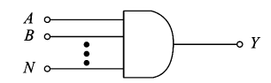

Pin Diagram:

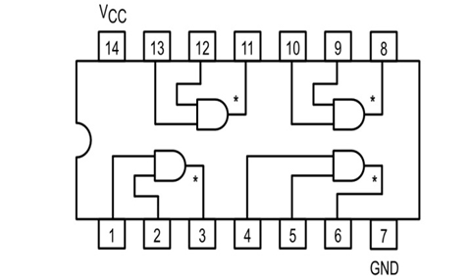
Truth Table:
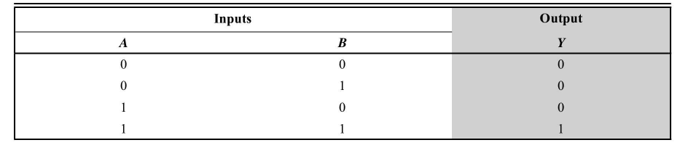

- OR Gate: Y = A+B+C+...+N
Symbol:
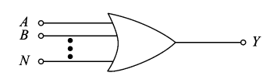

Pin Diagram:
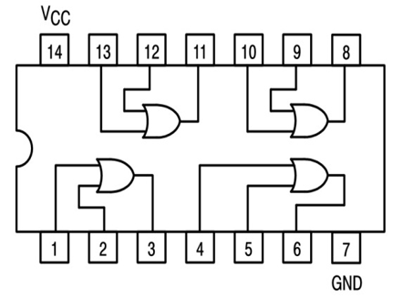
Truth Table:

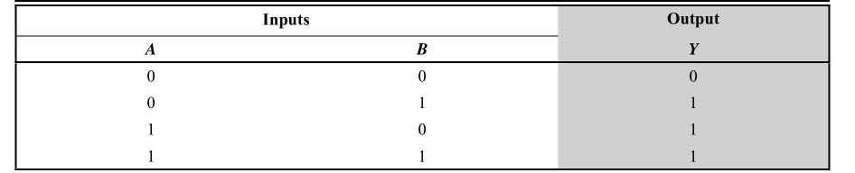
- NOT Gate: Y =
Symbol:
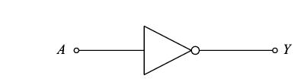
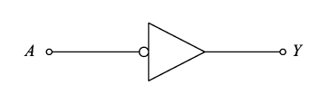

Pin Diagram:
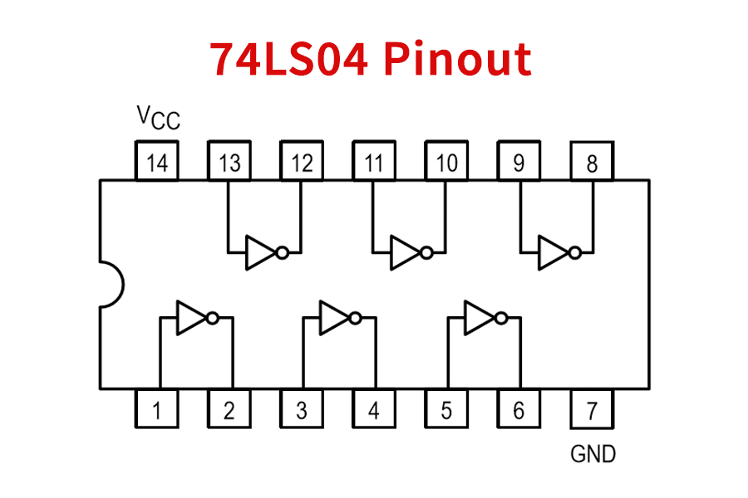
Truth Table:

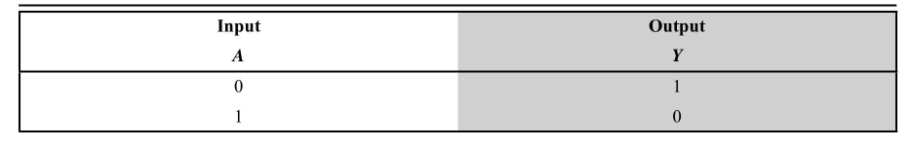
- NAND Gate: Y =
Symbol:
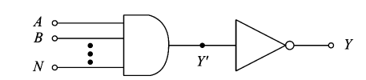
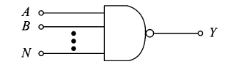

Pin Diagram:
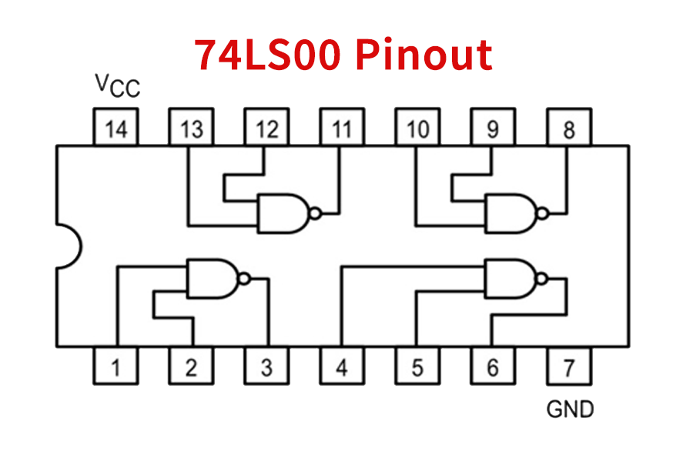
Truth Table:
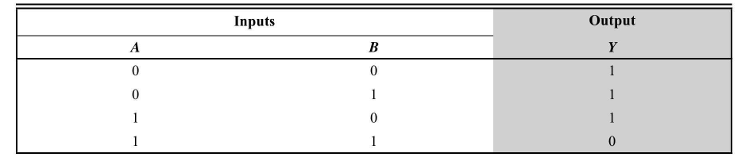
- NOR Gate: Y =
Symbol:
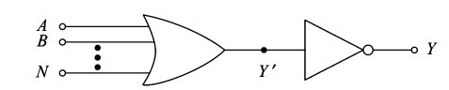
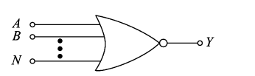
Pin Diagram:

Truth Table:

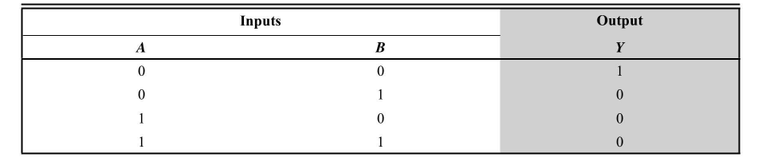
- XOR Gate: Y =
Symbol:
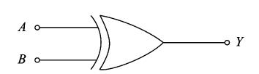

Pin Diagram:
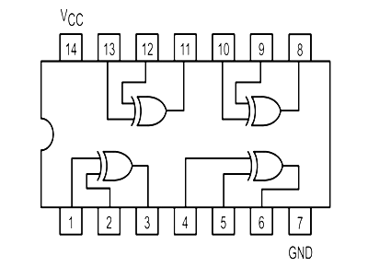
Truth Table:
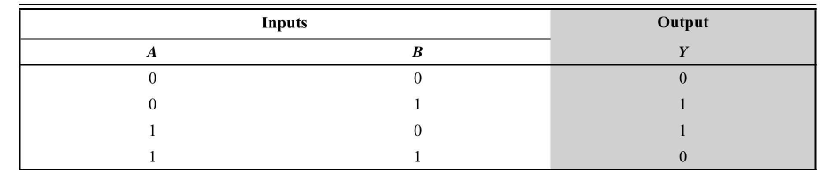

- XNOR Gate: Y =
Symbol:
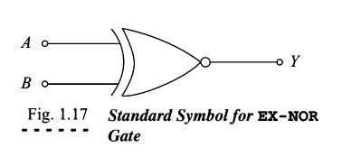

Pin Diagram:


Truth Table:
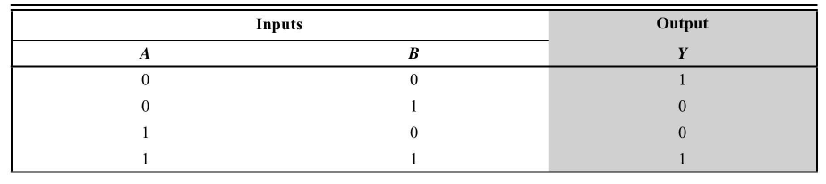

Implementation Using NAND Gate

NOT GATE
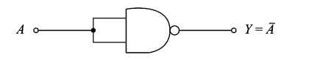

AND GATE
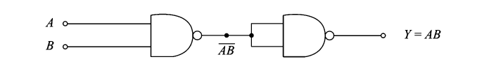

OR GATE
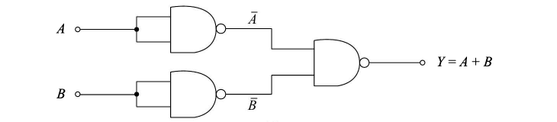

Implementation Using NOR Gate

NOT GATE
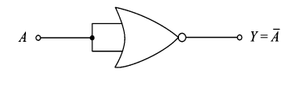

AND GATE

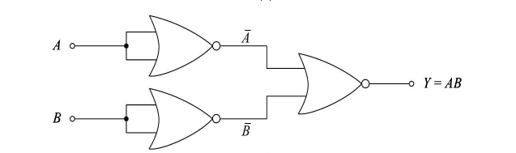

OR GATE

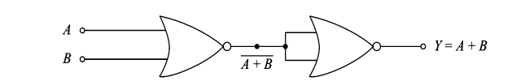

Post Lab Subjective/Objective type Questions:
- Implement the Boolean function using NAND gates and NOR gates F=A’B + AB’
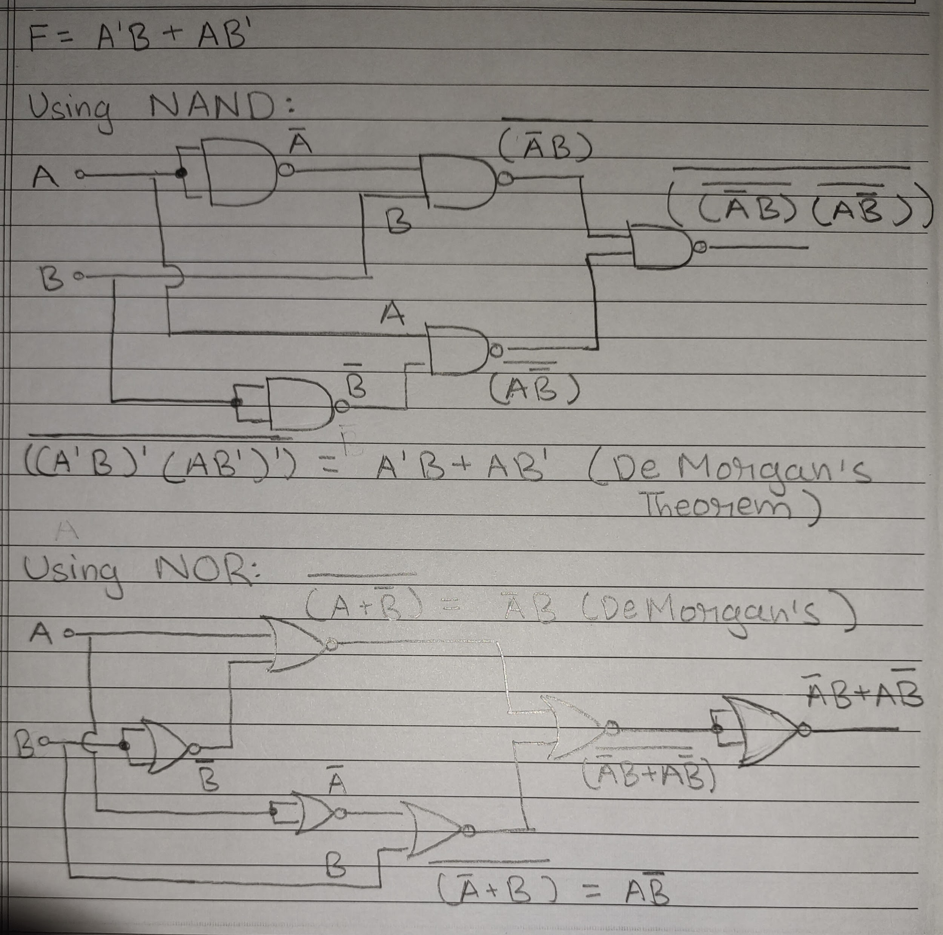

- Implement using combination of gates F = ABC + AB’C + ABC’
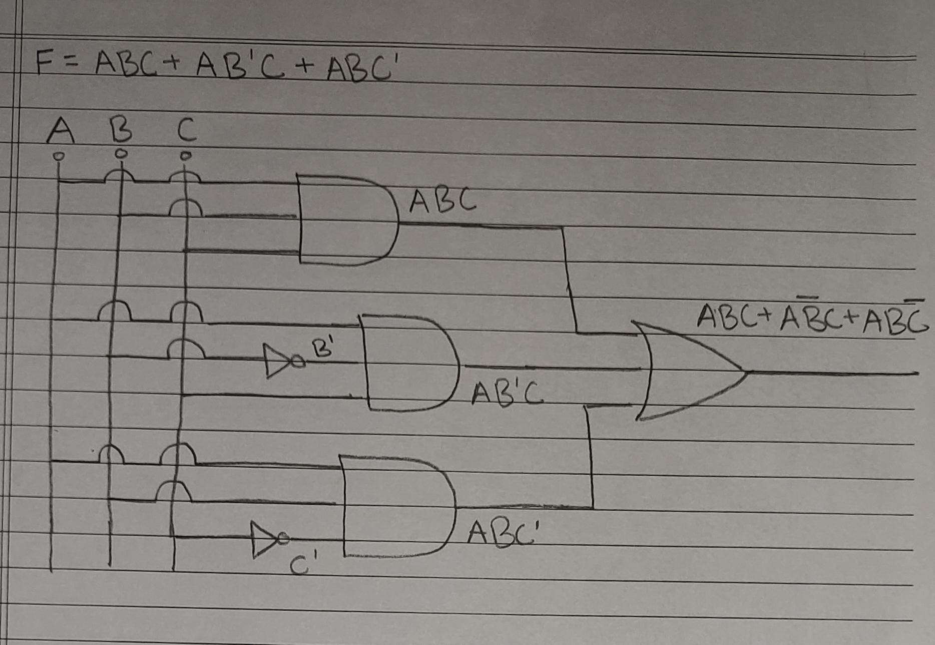

Conclusion:
In conclusion, this experiment provided an invaluable hands-on experience in comprehending the fundamental concepts of logic gates and universal gates.

We began by delving into the realm of basic logic gates, unraveling the operations of AND, OR, NOT, NAND, NOR, and XOR gates. Through practical experimentation, we witnessed firsthand how these gates can be used to manipulate binary information, laying the foundation for more complex digital circuits.

Furthermore, our exploration extended to universal gates, where we discovered their unique ability to perform any logical operation when properly interconnected. This versatility highlighted the importance of universal gates as pivotal components in digital circuit design.

Signature of faculty in-charge with Date:

